Authors: Issah Abakar

Advisor: Dr. Eric Owusu

SUNY Brockport  
Brockport, NY

nightlife



Contents

Introduction: 1

System Description 3

Functional requirements: 3

Non-Functional requirements: 4

Feasibility Assessment: 4

Use Case Diagram: 5

Logical Context diagram: 6

Physical CONTEXT Diagram: 7

Physical CONTEXT Diagram 13

Night Life Interface design: 14

Interface structure diagram (ISD): 22

Structure chart: 23

Pseudo code: 26

Test plans: 29

Testing: 39

Research interview questions: 41

Team Management and 47

Data dictionary: 48

Scenarios 49

Transition 53

Work cited: 53

# Introduction:

**Basic Idea:**

Night Life is a smart thermal car camera that features a powerful thermal imaging system for nighttime driving that helps drivers detect road hazards in total darkness as well as functioning as a regular dash camera. It detects and alerts the user when they come across objects that emit heat such as vehicles, people, and animals that the driver may be unable to see in low light areas, allowing drivers to see farther than their headlights. This allows drivers to see pediatricians and wildlife coming regardless of the driving conditions they’re dealing with. The footage is also automatically uploaded for the user to access via the app when the device has obtained an internet connection. It provides enhanced visibility no matter the light or weather conditions and helps improve vehicle safety. The device itself attaches to a vehicle's front and back, but only the front display screen will relay alerts.

**Proposes, how it would work or would look, and target audience of the product:**

This device is made up of an app and dash cameras with thermal capabilities and the ability to record high-resolution videos, even in the dark. The dashcam automatically starts recording when the vehicle starts and turns off and when the car is turned off. The dash cam also comes with a parking mode. Which monitors the car’s surroundings while the car is parked, this means the device automatically starts recording when movement is detected and stops recording when no continued movement near the vehicle is detected.

The app makes it easier to access the content the device records without having to physically remove the SD card from the dash camera to access the recording. This means users don't have to worry about readjusting(remounting) the dashcam to its original position if they need to remove the SD card, which saves time and the fear of damaging the dashcam or the SD card during that process.

When the device detects a collision, it stores footage, including audio, in an easily accessible folder on the SD card for seven days. Since the SD cards must be cleared at some point so the device does not cease to function, When the device obtains an internet connection it uploads the video to the videos folder within the Night Life app, videos that have been flagged as containing possible collisions are uploaded to the collisions folder. Also, it is possible for the user to favorite any video for easy access and those favorite videos will be in the favorites folder. This allows users to easily access their past recordings and the settings to everything via the app.

Our target audience for this product is commuters who often must drive long distances or in less-than-ideal conditions. Most likely in a rural area.

**Desire/demand.**

People who have long-distance commutes as part of their daily routines would find this product very useful, especially if they need to drive at night. After a long day with whatever they may have been doing, having the extra security of Night Life may help you feel so much more safe and secure, knowing that your safety does not fully depend on your ability to notice everything. Having Night Life help you monitor your surroundings for possible threats can help anyone feel more secure in their vehicle, not just in high-stress situations such as highly populated areas and poor driving conditions.

# System Description

**Outputs**: Alert notification, verification email, visual warning, audible warning, display object distance, video feed

**Inputs**: road hazard, account information, radar sensor, car information, Bluetooth

**Processes**: First-time login, connect phone to car and record, detect road hazard, upload video feed, purge videos after 30 days

# Functional requirements:

* The system must turn on automatically when the vehicle starts and allow the user to toggle between the regular dash camera option and the thermal imaging camera when they press a button​.
* The system should have the ability to remember the vehicle after one login, so the user does not have to log in every time they start their vehicle​.
* The system should alert the user of potential driving hazards or animals within 150 feet.​
* The system should automatically upload footage to be accessed via an app on the user's mobile device and delete the footage after 30 days to allow continuous room for new footage. ​
* The system should turn off automatically when the vehicle turns off​.

# Non-Functional requirements:

* **Operational** – The physical environment for the camera is the technician installing the camera into the vehicle​.
* **Performance** – The camera records footage both thermal and non-thermal at 4k resolution, and has a standard capacity of 256GB of storage, with the option to add more via a micro-SD card up to 512GB.​
* **Security** - The recorded data is stored on the device until it gets connected to the internet and then automatically deleted from the device. The footage is stored in the cloud that is professionally monitored by our company.​
* **Cultural and Political** - The only regulations that could be placed are if the government decides the camera can't be used in highly populated areas due to privacy.​

# Feasibility Assessment:

**Economic:** If the thermal camera cost $1,000 to initially get installed on the vehicle, it will save thousands of dollars if the car avoids the accident. Bodywork to fix the vehicle can easily cost well over $1,000​**.**

**Technical:** Using this software will initially be new but the act of connecting your phone to the car will follow all the traditional steps​.

**Organizational:** Business objectives would be to sell/market the camera to avoid expensive damage to personal vehicles

**Legal & Contractual:** Legal and contractual would relate to how well the camera performs. The camera needs to have legal documentation to back it up if the camera failed the company can't be at fault​ and local and international Government regulations of thermal sensors​.

**Political**: Politically, the government can regulate if or when the camera is allowed to be used, an example to be seen today is that fully automated driving isn't legal yet. The schedule for this project should be laid out in the project outline for how long it should take to build and produce​.

**Schedule** – Timeline: The system should be completed within 14 weeks​.

# Use Case Diagram:

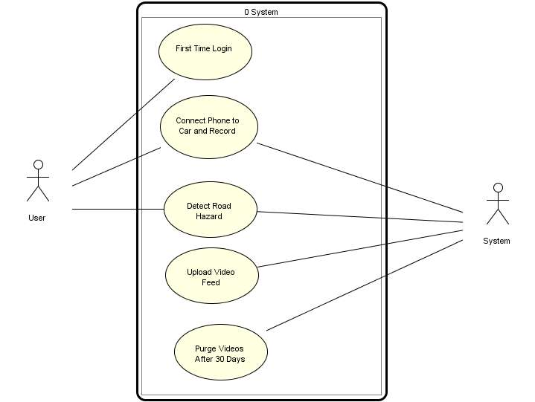

Figure 1 Night Life Use Cases

# Logical Context diagram:

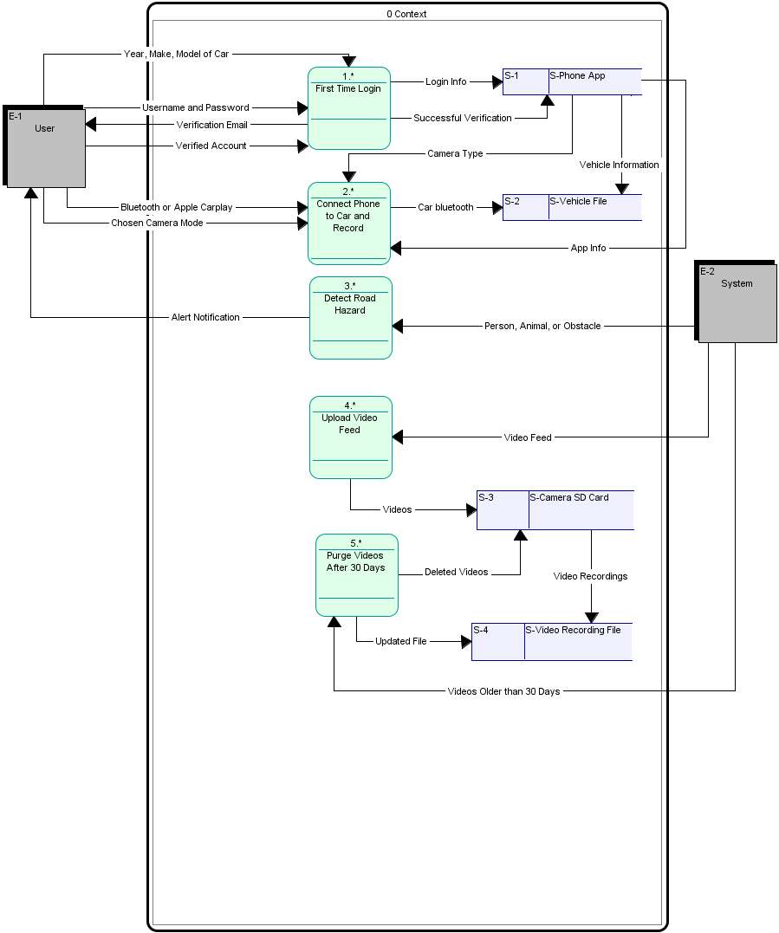

Figure 2 Night Life Logical Context diagram

# Physical CONTEXT Diagram:

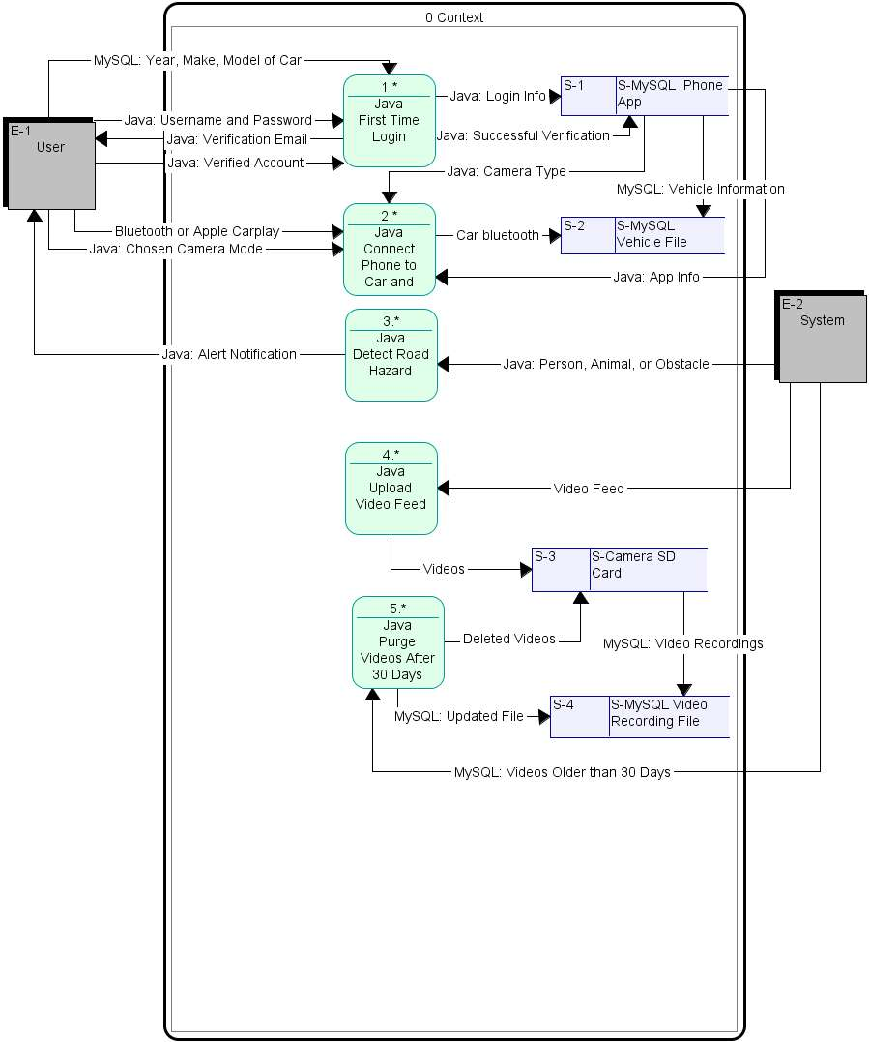

Figure 3 Night Life Physical CONTEXT Diagram

**First-Time Login:**

Figure 4 First-time login sub-process

**Connect Phone to Car:**

Figure 5 Connect Phone to and Record Sub-Process

**Detect Road Hazard:**

Figure 6 Detect Road Hazard Sub-Process

**Upload Video Feed:**

Figure 7 Upload video Feed subprocess

**Purge videos after 30 days:**

Figure 8 Purge After 30 days sub-process

# Physical CONTEXT Diagram



Figure 9 Physical CONTEXT Diagram

# Night Life Interface design:

**Demo:** [**Figma prototype demo**](https://www.figma.com/proto/b4spqZLTMn1z0Ebc36HhJM/App?node-id=9-2904&scaling=scale-down&page-id=0%3A1&starting-point-node-id=9%3A2904)

Figure 10 Night Life Login page

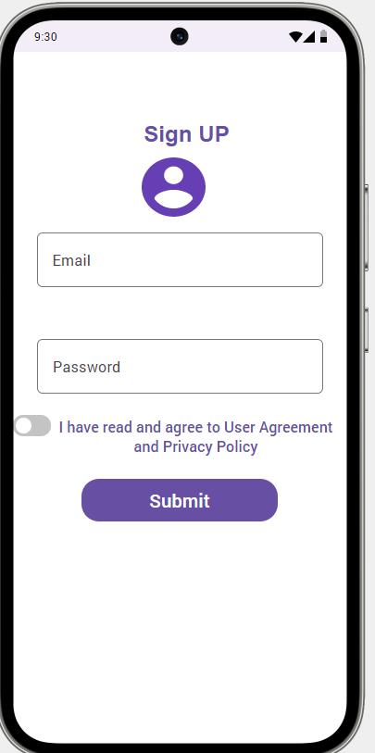

Figure 11 Night Life Sign Up page

Figure 12 Night Life Home Page

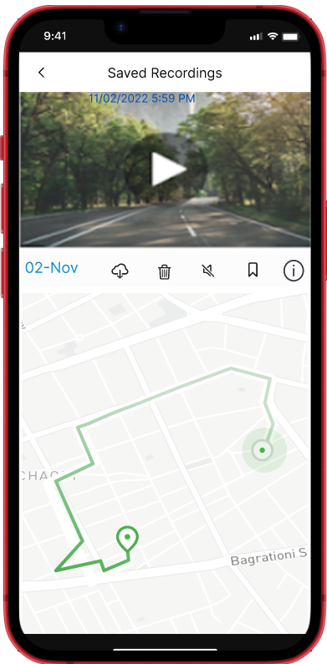

Figure 13 Night Life Saved Rec

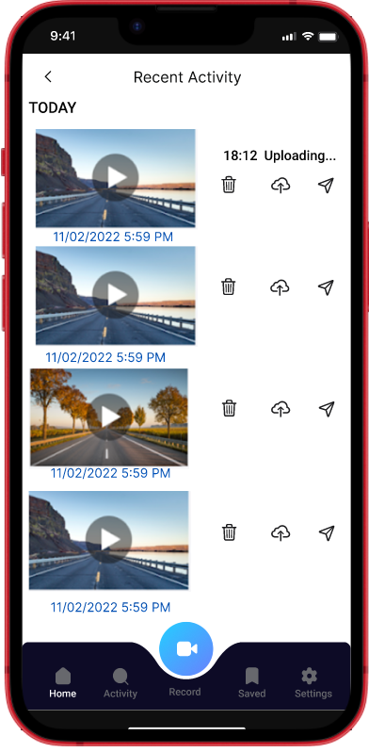

Figure 14 Night Life Saved Folder

Figure 15 Night Life Settings Page

Figure 16 Night Life Search and Add device.

Figure 17 Night Life Search and Add device.

# Interface structure diagram (ISD):

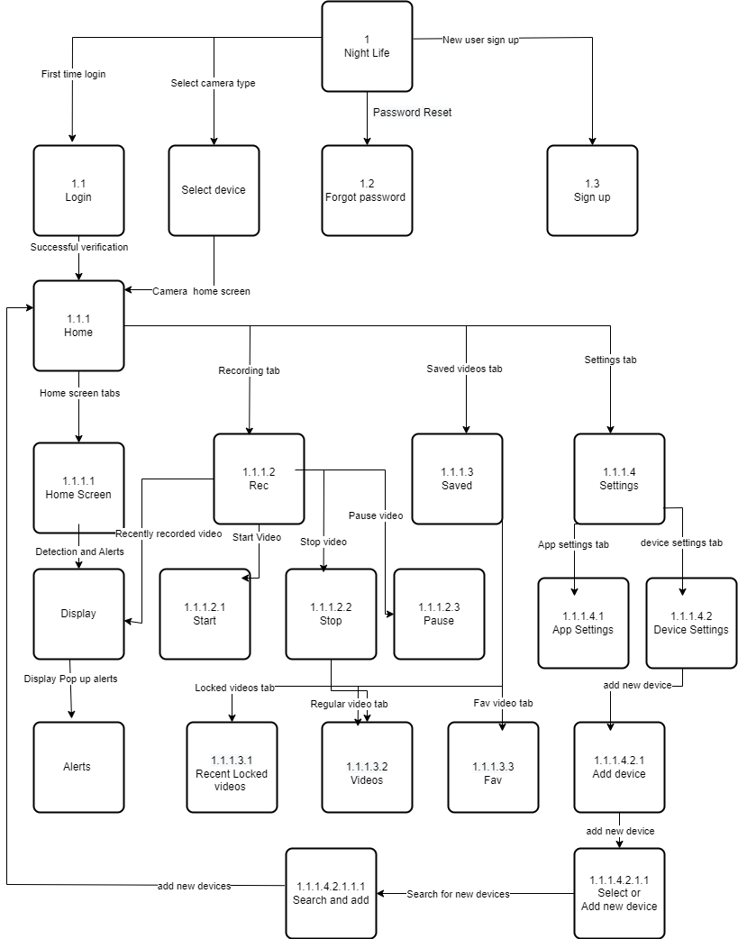

Figure 17 Interface structure diagram (ISD):

# Structure chart:

Figure 18 Structure chart

**Structure chart:** First-time login

Figure 19 Structure chart: First-time login

**Structure chart:** Connect phone to car

Figure 20 Structure chart: Connect phone to car.

**Structure chart:** Detect Road Hazard

Figure 21 Structure chart: Detect Road Hazard

**Structure chart:** upload video Feed.

Figure 22 Structure chart: upload video Feed.

**Structure chart:** Purge videos after 30 days.

Figure 23 Structure chart: Purge videos after 30 days

# Pseudo code:

1. //First-time login Pseudocode​

Get Email​

Get Password​

IF (Email==DBEmail && password == DBPassword) THEN

​login Success​

ELSE​

Login Failed.​

ENDIF​

//Sign up Pseudocode​

GET First Name

GET Last Name

Get Email

Get Password

Get VIN

IF (validate_Email(Email) && validate_Vin(VIN))THEN

Sign up Success

DISPLAY login_page

ELSE

DISPLAY Sign up Error

ENDIF

2.//Connect Phone to Car & Record Pseudocode​

IF Settings is selected THEN

DISPLAY nearby devices

IF device is selected THEN

CALL connect (device)

DISPLAY record button

ELSE

DISPLAY connection error

ENDIF

ENDIF

3.0// Detect Road Hazard Pseudocode​

WHILE record is selected

GET video frames from camera

CALL detect (video frames)

IF object is detected THEN

DISPLAY Alert

CALL store_to_collisions(video frame)

ELSE

CONTINUE

ENDIF

CALL store_to_videos(frames)

ENDWHILE

4.// Upload Video Feed Pseudocode​

CALL connection_status()

IF connection is detected THEN

REPEAT

GET videos form videos folder

GET collisions from videos folder

CALL upload to server(videos,server)

UNTIL videos in collisions and videos folder is empty

IF Success THEN

DISPLAY homepage

ELSE

DISPLAY

Error while uploading videos please try again

ENDIF

ENDIF

5. //Purge Videos After 30 Days Pseudocode​

GET videos from videos folder

CALL video_time_date_stamps(videos)

IF timestamps is greater than 30 days THEN

CALL purge(video)

ENDIF

DISPLAY home page

# Test plans:

**Program ID:** First-Time Login**:**

|  |
| --- |
| **Test Plan** Page 1 of 1  **Program ID:** First-Time Login **Version Number:** 1.0  **Tester:** Nick/Scott/Mackenzie/Issah **Date Designed:** 12/7/2022 **Date Conducted:** 12/7/2022  **Results: Passed Open Items** |
| **Test ID:** 1 **Requirement Addressed:** Verify that the user can successfully login on the mobile app  **Objective:** Test to see if the system will allow the user to create an account/login for the first time. |
| **Test Cases**  Interface ID Data Field Value Entered  1) 1.1 Access User Information Enter user email, password    2) 1.2 Access VIN Enter vehicle VIN  3) 1.3 Create Account/Login Enter login info. |
| **Script**  Case 1:  DISPLAY ‘Enter E-mail Address:’  User Enters: [*Exampleemail@example.com*](mailto:Exampleemail@example.com)  DISPLAY ‘Enter Password’  User Enters: *Password*  DISPLAY ‘Enter VIN (Vehicle Identification Number)’  User Enters: *XXXXXXXXXXXXXXXX*  DISPLAY ‘Account Created Successfully’  Case 2:  DISPLAY ‘Enter E-mail Address:’  User Enters: [*Exampleemail@example.com*](mailto:Exampleemail@example.com)  DISPLAY ‘Invalid Email Address. Please try again’  Case 3:  DISPLAY ‘Enter Password’  User Enters: *Password*  DISPLAY ‘Invalid Password. Please Try Again or Click Here to Reset’  Case 4:  DISPLAY ‘Enter VIN (Vehicle Identification Number)’  User Enters: *XXXXXXXXXXXXXXXX*  DISPLAY: ‘Invalid VIN. Please Enter a Valid VIN. |
| **Expected Results/Notes**   * 1. - The expected results are that the user information is requested by the system and the user inputs the information. The system then sends the info to module 1.3.   2. - The expected results are that the system prompts for and obtains the VIN before sending the information (as well as the info from module 1.1) to module 1.3.   3. - The expected results are that the system uses the information from modules 1.1 and 1.2 to create an account for the user that allows them to login. |
| **Actual Results/Notes**   * 1. - The actual results are that the system requests user information before the user enters it. The system then sends the info to module 1.3.   2. - The actual results are that the system prompts for and obtains the VIN before sending the information (as well as the info from module 1.1) to module 1.3.   3. - The actual results are that the system uses the information from modules 1.1 and 1.2 to create an account for the user that allows them to login. |

**Program ID:** Connect Phone to Car & Record**:**

|  |
| --- |
| **Test Plan** Page 1 of 1  **Program ID:** Connect Phone to Car & Record **Version Number:** 1.0  **Tester:** Nick/Scott/Mackenzie/Issah **Date Designed:** 12/7/2022 **Date Conducted:** 12/7/2022  **Results: Passed Open Items** |
| **Test ID:** 1 **Requirement Addressed:** Verify that the system can connect to the user’s mobile device via the app and begin recording.  **Objective:** Test to see if the phone can be connected to the car and if the system is able to begin recording successfully. |
| **Test Cases**  Interface ID Data Field Value Entered  1) 2.1 Access Vehicle Information    2) 2.2 Pair Device to Car Bluetooth Code  3) 2.3 Record |
| **Script**  Case 1  DISPLAY ‘Nearby Devices:’  User Enters: *Vehicle X*  DISPLAY: ‘Enter Bluetooth Code Displayed on Screen’  User Enters: XXXXXX  DISPLAY: ‘Device Paired Successfully’  User Selects: *Record*  DISPLAY ‘Recording…’  Case 2  DISPLAY ‘Nearby Devices:’  User Enters: *Vehicle X*  DISPLAY: ‘Enter Bluetooth Code Displayed on Screen’  User Enters: XXXXXX  DISPLAY: ‘Connection Error’ |
| **Expected Results/Notes**   * 1. - The expected results are that the vehicle information is accessed and sent to module 2.2.   2. - The expected results are that the vehicle displays a Bluetooth code for the device to enter so it can successfully pair, allowing the system to connect with the camera.   3. - The expected results are that the system will be able to record once paired with the car/camera. |
| **Actual Results/Notes**   * 1. - The actual results are that the vehicle information is accessed and sent to module 2.2.   2. - The actual results are that the vehicle displays a Bluetooth code for the device to enter so it can successfully pair, allowing the system to connect with the camera.   3. - The actual results are that the system will be able to record once connected with the car/camera. |

**Program ID:** Detect Road Hazard**:**

|  |
| --- |
| **Test Plan** Page 1 of 1  **Program ID:** Detect Road Hazard **Version Number:** 1.0  **Tester:** Nick/Scott/Mackenzie/Issah **Date Designed:** 12/7/2022 **Date Conducted:** 12/7/2022  **Results: Passed Open Items** |
| **Test ID:** 1 **Requirement Addressed:** Verify that the system can successfully detect road hazards and alert the user.  **Objective:** Test to see if the system will identify road hazards and alert the user. |
| **Test Cases**  Interface ID Data Field Value Entered  1) 3.1 Access Hazard Information Wildlife/Roadblock/Accident    2) 3.2 Alert User of Hazard |
| **Script**  Case 1:  IF object is detected  DISPLAY ‘Alert!’ |
| **Expected Results/Notes**   * 1. - The expected results are that the details of the hazard are taken in by the system and sent to module 3.2.   2. - The expected results are that the system will alert the user. |
| **Actual Results/Notes**   * 1. - The actual results are that the details of the hazard are taken in by the system and sent to module 3.2.   2. - The actual results are that the system will alert the user. |

**Program ID:** Upload Video Feed**:**

|  |
| --- |
| **Test Plan** Page 1 of 1  **Program ID:** Upload Video Feed **Version Number:** 1.0  **Tester:** Nick/Scott/Mackenzie/Issah **Date Designed:** 12/7/2022 **Date Conducted** 12/7/2022  **Results: Passed Open Items** |
| **Test ID:** 1 **Requirement Addressed:** Verify that the system can upload the video feed every time an internet connection is established.  **Objective:** Test to see if the system can upload the video feed every time an internet connection is established. |
| **Test Cases**  Interface ID Data Field Value Entered  1) 4.1 Access Video Feed    2) 4.2 Upload Video Feed |
| **Script**  Case 1:  DISPLAY ‘Choose Internet Connection’  User Enters: *MySpectrumWiFi*  DISPLAY ‘Enter Password’  User Enters: XXXXXX  DISPLAY ‘Video Feed Uploaded’  DISPLAY ‘Home Page’  Case 2:  IF bad/no internet connection  DISPLAY ‘Error while uploading videos’ |
| **Expected Results/Notes**   * 1. - The expected results are that the system will access the video feed and send the info to module 4.2.   2. - The expected results are that the system will upload the video feed to the cloud, which can then be accessed directly via the app. |
| **Actual Results/Notes**   * 1. - The actual results are that the system will access the video feed and send the info to module 4.2.   2. - The actual results are that the system will upload the video feed to the cloud to be accessed via the app. |

**Program ID:** Purge Video After 30:

|  |
| --- |
| **Test Plan** Page 1 of 1  **Program ID:** Purge Video After 30 Days **Version Number:** 1.0  **Tester:** Nick/Scott/Mackenzie/Issah **Date Designed:** 12/7/2022 **Date Conducted:** 12/7/2022  **Results: Passed Open Items** |
| **Test ID:** 1 **Requirement Addressed:** Verify that the system can effectively purge the video feed after 30 days.  **Objective:** Test to see if the system can purge the video files older than 30 days to free up space for new video. |
| **Test Cases**  Interface ID Data Field Value Entered  1) 5.1 Access Video Files Video Feed    2) 5.2 Delete Files Older Than 30 Days Video Info |
| **Script**  Case 1:  GET Videos from video folder  IF timestamp is greater than 30 days  THEN purge video  DISPLAY ‘Home Page’ |
| **Expected Results/Notes**   * 1. - The expected results are that the video files are accessed by the system and the information is sent to module 5.2.   2. - The expected results are that the videos are deleted after 30 days to free storage space for newly recorded videos. |
| **Actual Results/Notes**   * 1. - The actual results are that the video files are accessed by the system and the information is sent to module 5.2.   2. - The actual results are that the videos are deleted after 30 days to free storage space for newly recorded videos. |

# Testing:

|  |  |
| --- | --- |
| **Step** | **Description** |
| **1** | **Install Camera** |
| **2** | **Download app** |
| **3** | **Create account** |
| **3a** | **Enter personal and vehicle information** |
| **4** | **Verification** |
| **5** | **First-time login** |
| **5a** | **Incorrect username or password** |
| **6** | **Get in car** |
| **7** | **Open settings on phone** |
| **7a** | **Bluetooth to car** |
| **7b** | **Connect to apple car play** |
| **8** | **Press record** |
| **9** | **Begin driving** |
| **8a** | **Pause recording** |
| **8b** | **Stop recording** |
| **9** | **Get video frames** |
| **9a** | **Detect object** |
| **10** | **Alert user** |
| **11** | **Connect to internet** |
| **12** | **Upload videos** |
| **12a** | **Remove videos older than 30 days** |
| **12b** | **Update video file** |

# Research interview questions:

**Issah Abakar:**

Friday 11/5/22, Sunny Brockport, 1:43 pm-3:00 pm

Interviewee: [Mackenzie HIddie],

**Q: Do you find the interface difficult to understand?**

A: I don’t understand distance very well, but it would be good to know something is nearby, but otherwise as it was explained I think it makes sense. Just make sure the person know what the numbers flashing on the screen mean.

**Q: What other ways do you think the device should alert you of an obstacle?**

**(other than flash screen and sound)**

A: Maybe have something like in my mom’s car where it projects a little red laser onto the windshield when she gets too close to other cars.

**Q: Would being able to adjust how the device outputs its results be helpful?**

A: Yes, I think so because the flash could be distracting at night and i feel like i would pay attention to the sound more

A: Another person, listing to us said he would prefer just to have the screen because music so loud

**Q: Would footage of the front and the back of the vehicle be helpful or do you find it unnecessary?**

A: During normal driving I find it unnecessary, but if I was backing up or maneuvering if i could use it as a backup camera. That would be nice.

**Q: Would some kind or visual or sound indicator of the device being on be helpful to you?**

A: Personally I don't think I would like a screen flash, but in terms of sound, I would like something that isn’t scary because I scare easily, not like an alarm noise or anything like a fun beep.

**Q: What kind of things do you think this device should be able to detect?**

A: Like people and deer... or potholes I'd kill for something that told me when there were potholes. If the thing can't see like small animals I think that's fine, because they're a lot of small creatures that run around so it'd probably be distracting to look for them too.

(she meant like squirrels and birds)

**Q: Have you ever been involved in an accident with a pedestrian or animal?**

A: no, knock on wood.

**Q: Would you prefer the device to have a rechargeable or changeable battery, or just have it as it is with the device being powered by being plugged into the cigarette lighter?**

A: cigarette lighter, because i would for sure forget about it if i had to bring it in to charge it. I’m an out of sight out of mind kind of person.

**Q: What other kinds of features do you wish dash cams/detector devices had?**

A: Like recording and storing the driving footage, but I think they already do that.

**Q: Is there any specific reason you currently do/do not have a dash cam?**

**If no: Would you ever buy one?**

A: I'm actually asking for one for Christmas, like i want one but i never really done the work and research to get one but that’s why I’m making someone else do for me.

**Scott Van Alstine:**

Saturday 11/6/22, Turtle South Sunny Brockport, 6:01 pm

Interviewee: [Nick Farrell]

**Q: Do you find the interface difficult to understand?**

A: No, it seems simple enough to understand.

**Q: What other ways do you think the device should alert you of an obstacle?**

**(other than flash screen and sound)**

A: If maybe you add a vibration part to it then anyone can get it if they are deaf or blind or not.

**Q: Would being able to adjust how the device outputs its results be helpful?**

A: Yes, I think so because not everyone likes the same things as everyone else I prefer to have both a sound and a flash.

**Q: Would footage of the front and the back of the vehicle be helpful or do you find it unnecessary?**

A: I believe it would be helpful if not for having as a dash cam you can use it for other stuff like parking and making sure you won’t back upon a person.

**Q: Would some kind of visual or sound indicator of the device being on be helpful to you?**

A: It would be great if you could like have custom indicators like if something was behind me I want to put something like a guy yelling stop.

**Q: What kind of things do you think this device should be able to detect?**

A: You know most things it should like animals and people but also things like walls other cars and those bumps and pipes some stores have when you go to park.

**Q: Have you ever been involved in an accident with a pedestrian or animal?**

A: No but I did come close good thing it was in the afternoon not night cause I would have hit that deer.

**Q: Would you prefer the device to have a rechargeable or changeable battery, or just have it as it is with the device being powered by being plugged into the cigarette lighter?**

A: Me personally I would like it if was rechargeable but could hold that charge for a long time and doesn’t run out at night.

**Q: What other kinds of features do you wish dash cams/detector devices had?**

A: Being able to upload the footage to my email or just an account where I can keep a record of it.

**Q: Is there any specific reason you currently do/do not have a dash cam?**

**If no: Would you ever buy one?**

A: I have one since I have an old car and it doesn’t come with a way to record stuff that happens to me and I don’t want to be liable for anything

**Nick Farrell:**

Sunday 11/7/22, Buffalo, NY, 1 pm

Interviewee: [Scott Van Alstine]

**Q: Do you find the interface difficult to understand?**

A: No, the visual and workday icons makes it easier for users to interact with it. Its a simple layout software that is easy to navigate.

**Q: What other ways do you think the device should alert you of an obstacle?**

**(other than flash screen and sound)**

A: I believe that the flashing screen which is visual alert and sound which is noise alert is good enough to alert the obstacle coming up for the drivers.

**Q: Would being able to adjust how the device outputs its results be helpful?**

A: Flashing can sometimes be ignored while the driver is focusing on the road. The noise added to it at the same time helps the driver to make sure take a look at the alert type and move forward along the road with precautions.

**Q: Would footage of the front and the back of the vehicle be helpful, or do you find it unnecessary?**

A: The front and back footage of the vehicle is going to help in keeping proof of any collision that is with other vehicles. It keeps track of how and when the other vehicle has had collision with the user's vehicle. If anything happens we can go through our driving footage to find out. These make it helpful to keep both front and back footage of the vehicle.

**Q: Would some kind or visual or sound indicator of the device being on be helpful to you?**

A: Yes the visual and sound indicator alerts me to stay alert for any obstacle coming up.

**Q: What kind of things do you think this device should be able to detect?**

A: I live in buffalo and there are lots of state parks around us. In the park there are deer’s that tend to cross the road very often at night where there are no street lights. I suggest the device should detect deer mostly to keep drivers alert and safe of running into an accident with the deer. The cam should also detect bicycles that ride at night so that we do not collide with bicycles with less reflectors.

**Q: Have you ever been involved in an accident with a pedestrian or animal?**

A: No, I have never been in an accident with a pedestrian or and animal but there are several times where I almost collided with a deer.

**Q: Would you prefer the device to have a rechargeable or changeable battery, or just have it as it is with the device being powered by being plugged into the cigarette lighter?**

A: I prefer a rechargeable battery because one way there is no wire tangling in the windshield where we place the device. If the wiring is done correctly clean and tidy then i believe the wire being plugged in the cigarette lighter is fine too.

**Q: What other kinds of features do you wish dash cams/detector devices had?**

A: Have cloud recording where we can access the footage from any device and not lose the footage if the device is broken.

**Q: Is there any specific reason you currently do/do not have a dash cam?**

**If no: Would you ever buy one?**

A: I do have a dash cam attached to my car. It helps keep track of my drives and keeps me safe from other obstacles and keeps footage of the collision so that the insurance can help see the collision before charging me for hefty repair costs.

**Mackenzie HIddie**:

Date & Time :11/05/2022, 12:28 -1PM

Interviewee [Issah Abakar]

Location: Edward Hall Sunny Brockport

1. Do you find the interface difficult to understand?
   1. No i think it’s self-explanatory because of the icons
2. What other ways do you think the device should alert you of an obstacle?
   1. Sometimes it’s really hard to hear the alert sound when the music's too high, May be have the device pause the music and provide audible sounds
3. Would being able to adjust how the device outputs its results be helpful?
   1. When driving alone on quiet nights the flash and sound alert can be a bit frightening. I think a good approach should be to have the device make vibration on the steering wheel to alert the driver.
4. Would footage of the front and the back of the vehicle be helpful or do you find it unnecessary?
   1. No, I think that would be distracting especially when driving on a highway or bridge, because I suffer from gephyrophobia.
5. Would some kind or visual or sound indicator of the device being on be helpful to you?
   1. Yes because anything could happen in a single second, so having the device alert is very crucial it can save life and money
6. What kind of things do you think this device should be able to detect?
   1. any obstacles that can cause damage to car
7. Have you ever been involved in an accident with a pedestrian or animal?
   1. No, i always pay attention when driving and i consider myself pretty good driver
8. Would you prefer the device to have a rechargeable or changeable battery, or just have it as it is with the device being powered by being plugged into the cigarette lighter?
   1. I think it’s necessary to charge the device, because they battery might drain if the car is not driven in weeks, instead the device should be powered by being plugged into the cigarette light
9. What other kinds of features do you wish dash cams/detector devices had?
   1. Provide audible sounds when i’m too close to the front car
10. Is there any specific reason you currently do/do not have a dash cam?
    1. I’ve one incase of an accident and it help me report undisciplined drivers

# Team Management and

**Team Member Roles:**

Mackenzie Hiddie: Project Manager

Issah Abakar: Programmer

Scott Van Alstine: Systems Analyst

Nick Farrell: Business Owner

**Communication:**

Discord, E-mail, In person.

**Schedule:**

Timeline: 14 weeks

Meeting Times: 6:00 PM Every two weeks.

Meeting Places: Zoom/Teams, in class.

**Appendix:**

# Data dictionary:

User System

* Alert from system - Detect road hazards
* User name - Purge videos after 30
* Password - Upload video feed
* Connect phone to car
* Car year
* Car model
* Car make

# Scenarios

Figure 24 First Time Login Scenario

Figure 25 Connect Phone to Car & Record Scenario

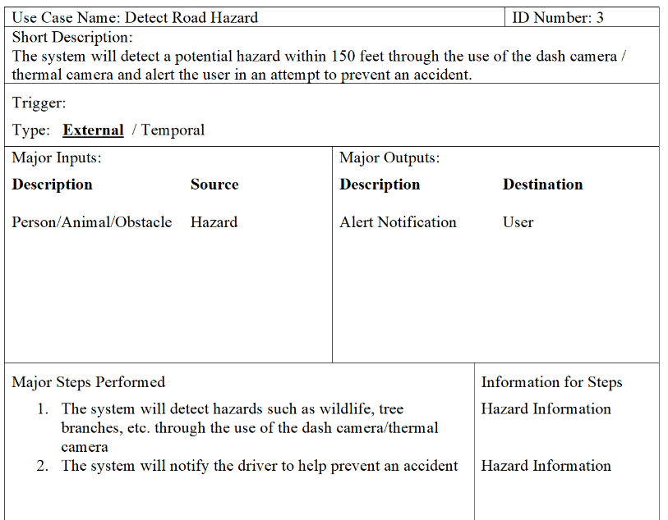

Figure 26 Detect Road Hazard Scenario

Figure 27 Upload video Feed Scenario

Figure 28 Purge Videos after 30 days Scenario

# Transition

A direct transition strategy would be used for this system since it is a new system. A direct transition strategy would minimize costs and time needed to complete the transition from a traditional dash camera setup. A parallel approach would be the most effective, but it would not make sense to install our system on a vehicle that already has a dash camera at the same time, so a direct approach would be the most appropriate.

# Work cited:

By, and The West Law Office. “Car Accidents Caused by Animals.” The West Law Office, PLLC, [https://www.houstonpersonalinjury.law/car-accidents-caused-by-animals/.](https://www.houstonpersonalinjury.law/car-accidents-caused-by-animals/. )